# Exercises: PHP Syntax, Basic Web

Problems for exercises and homework for the [“Software Technologies” course @ SoftUni](https://softuni.bg/courses/software-technologies).

You can submit your solutions here <https://judge.softuni.bg/Contests/236/PHP-First-Steps-Exercises>.

# Part I: Simple operations with PHP

Taking into account the nature of PHP we will receive input **not** from the console, as in C# or Java, but from **forms**, which will be **rendered** in the **browser**.

Every task in judge will have a **skeleton**, which will be an **HTML** skeleton of the form.

In each example, you will see new column named “**Parameter name**”. Every parameter, which should be passed to your program, should be received from input tag with exactly the same name parameter. All of the skeletons will be with the correct name parameters. If you write your own HTML make sure you use the **same** **names**.

## Multiply a Number by 2

You are given a number num. Write a PHP script that **multiplies** the **number by 2** and prints the result. The input comes as a parameter named num.

### Examples

|  |  |  |  |  |  |
| --- | --- | --- | --- | --- | --- |
| **Parameter name** | **Input** | **Output** |  | **Input** | **Output** |
| num | 2 | 4 |  | 3 | 6 |

You will be given a HTML form that submits the input data:

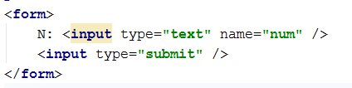

The name of the input parameter will be exactly as shown above – num.

Print the output in the HTML document, just after the HTML form.

### Hints

* In case the form was submitted and the input parameter num exists, take its value as integer using the function intval(string).

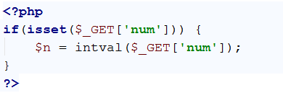

* Then, just print the results: echo $n * 2.

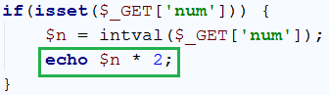

* Test whether your code worked as expected:







## Multiply Two Numbers

You are given a number num1 and a number num2. Write a PHP script that multiplies num1 * num2 and prints the result. The input comes as parameters named num1 and num2. Print the output in the HTML page.

### Examples

|  |  |  |  |  |  |
| --- | --- | --- | --- | --- | --- |
| **Parameters names** | **Input** | **Output** |  | **Input** | **Output** |
| num1 | 2 | 6 | 13 | 169 |
| num2 | 3 | 13 |

### Hints

* This time the form which will be given to use will have 2 input elements, with names num1 and num2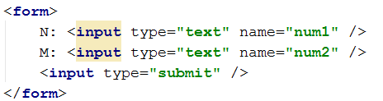
* We must check both elements, if they have values before we perform any action

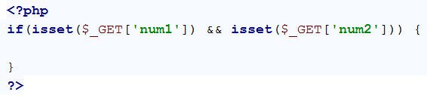

* When we have checked both elements we get them both and extract their values into variables and we perform the specified action:

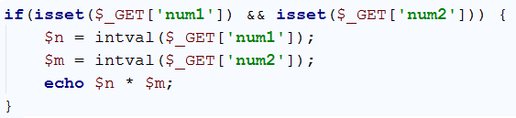

* The result is as follows:

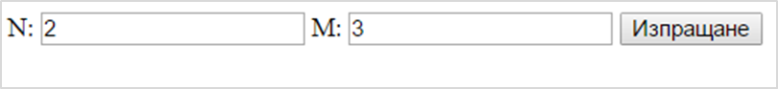

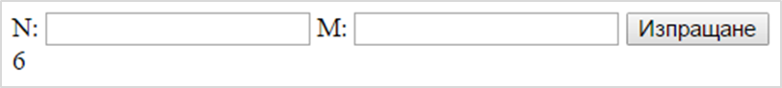

## Multiply / Divide Numbers

You are given a number num1 and a number num2. Write a PHP script that:

* Multiplies num1 * num2 if num2 is greater than or equal to num1.
* Divides num1 / num2 if num1 is greater than num2.

The input comes as parameters named num1 and num2. Print the output in the HTML page.

### Examples

|  |  |  |  |  |  |  |  |  |
| --- | --- | --- | --- | --- | --- | --- | --- | --- |
| **Parameters names** | **Input** | **Output** |  | **Input** | **Output** |  | **Input** | **Output** |
| num1 | 2 | 6 |  | 13 | 169 | 3 | 1.5 |
| num2 | 3 |  | 13 | 2 |

## Product of 3 Numbers

You are given a number num1, num2 and num3. Write a PHP script that finds if num1 * num2 * num3 (the product) is **negative** or **positive**. Try to do this **WITHOUT** multiplying the 3 numbers.

The input comes as parameters named num1, num2 and num3.

### Examples

|  |  |  |  |  |  |  |  |  |
| --- | --- | --- | --- | --- | --- | --- | --- | --- |
| **Parameters name** | **Input** | **Output** |  | **Input** | **Output** |  | **Input** | **Output** |
| num1 | 2 | Negative |  | 5 | Positive | -3 | Positive |
| num2 | 3 |  | 4 | -4 |
| num3 | -1 |  | 3 | 5 |

### Hints

* Count the **negative numbers**. If they are odd number, the result will be negative, otherwise 🡪 positive.
* Special case: one of the numbers is 0 🡪 the product is positive.

## Numbers from 1 to N

You are given a number num. Write a PHP script that loops through all of the numbers from 1 to num and prints them. The input comes as a parameter named num. The parameter num will hold a positive integer.

### Examples

|  |  |  |  |  |  |
| --- | --- | --- | --- | --- | --- |
| **Parameter name** | **Input** | **Output** |  | **Input** | **Output** |
| num | 5 | 1 2 3 4 5 |  | 2 | 1 2 |

## Numbers from N to 1

You are given a number num. Write a PHP script that loops through all of the numbers from num to 1 and prints them. The input comes as a parameter named num. The parameter num will hold a positive integer.

### Examples

|  |  |  |  |  |  |
| --- | --- | --- | --- | --- | --- |
| **Parameter name** | **Input** | **Output** |  | **Input** | **Output** |
| num | 5 | 5 4 3 2 1 |  | 2 | 2 1 |

## Even Numbers from 1 to N

You are given a number num. Write a PHP script that loops through all of the numbers from 1 to num and prints only the even ones. The input comes as a parameter named num. The parameter num will hold a positive integer.

### Examples

|  |  |  |  |  |  |
| --- | --- | --- | --- | --- | --- |
| **Parameter name** | **Input** | **Output** |  | **Input** | **Output** |
| num | 5 | 2 4 |  | 2 | 2 |

## Odd Numbers from N to 1

You are given a number num. Write a PHP script that loops through all of the numbers from num to 1 and prints only the odd ones. The input comes as a parameter named num. The parameter num will hold a positive integer.

### Examples

|  |  |  |  |  |  |
| --- | --- | --- | --- | --- | --- |
| **Parameter name** | **Input** | **Output** |  | **Input** | **Output** |
| num | 5 | 5 3 1 |  | 2 | 1 |

## N Factorial

You are given a number num. Write a PHP script that prints **factorial** of num. Factorial is calculated by multiplying all numbers to the given number. Factorial (N) = 1 * 2 * 3… * num. The input comes as a parameter named num. The parameter num will hold a positive integer.

### Examples

|  |  |  |  |  |  |
| --- | --- | --- | --- | --- | --- |
| **Parameter name** | **Input** | **Output** |  | **Input** | **Output** |
| num | 5 | 120 |  | 3 | 6 |

## Not Divisor Numbers

You are given a number num. Write a PHP script that prints all the numbers from num to 1**,** which are not divisors of num**.** The input comes as a parameter named num. The parameter num will hold a positive integer.

### Examples

|  |  |  |  |  |  |
| --- | --- | --- | --- | --- | --- |
| **Parameter name** | **Input** | **Output** |  | **Input** | **Output** |
| num | 10 | 9 8 7 6 4 3 |  | 12 | 11 10 9 8 7 5 |

## Fibonacci Sequence

You are given a number num. Write a PHP script that printsnumnumbers from The Fibonacci sequence, each on a new line, starting from 1. In the Fibonacci sequence, every number is formed from the sum of the previous 2. The input comes as a parameter named num. The parameter num will hold a positive integer.

### Examples

|  |  |  |  |  |  |
| --- | --- | --- | --- | --- | --- |
| **Parameter name** | **Input** | **Output** |  | **Input** | **Output** |
| num | 5 | 1 1 2 3 5 |  | 10 | 1 1 2 3 5 8 13 21 34 55 |

## Tribonacci Sequence

In the **“Tribonacci” sequence**, every number is formed by the **sum of the previous 3**.

You are given a number num. Write a PHP script that printsnumnumbers from the Tribonacci sequence, each on a new line, starting from 1. The input comes as a parameter named num. The value num will always be positive integer.

### Examples

|  |  |  |  |  |  |
| --- | --- | --- | --- | --- | --- |
| **Parameter name** | **Input** | **Output** |  | **Input** | **Output** |
| num | 4 | 1 1 2 4 |  | 8 | 1 1 2 4 7 13 24 44 |

## Prime Numbers from N to 1

You are given a number num. Write a PHP script that printsonly the **prime** numbers from num to 1. A prime number is a number that can be divided only by 1 and itself. **1 is not a prime number.** The input comes as a parameter named num. The parameter num will hold a positive integer.

### Examples

|  |  |  |  |  |  |
| --- | --- | --- | --- | --- | --- |
| **Parameter name** | **Input** | **Output** |  | **Input** | **Output** |
| num | 10 | 7 5 3 |  | 20 | 19 17 13 11 7 5 3 |

# Part 2: Manipulating HTML with PHP

## HTML Buttons

You are given a number num. Write a PHP script that **generates HTML <button> elements.** The buttons must hold a number from 1 to num as their caption. The input comes as a parameter named num, holding a positive integer.

There is no indentation on the elements.

### Examples

|  |  |  |  |
| --- | --- | --- | --- |
| **Parameter name** | **Input** | **Output** | **Picture** |
| num | 3 | <button>1</button>  <button>2</button>  <button>3</button> |  |
| num | 5 | <button>1</button>  <button>2</button>  <button>3</button>  <button>4</button>  <button>5</button> |
| num | 1 | <button>1</button> |

## Sub-Lists

You are given a number num1 and a number num2. Write a PHP script that generates a list with **num1** elements, and each of those elements has a sub-list with **num2** elements. Each of the Lists has a caption “**List #**” where #is the current number from 1 to num1**.** And each of the elements of those lists has a caption “**Element #.#**” where the first # is the current list number and the second **#** is the current element from 1 to num2. The input comes as two parameters named num1 and num2, holding positive integers.

### Examples

|  |  |  |  |
| --- | --- | --- | --- |
| **Parameters names** | **Input** | **Output** | **Picture** |
| num1 | 1 | <ul>  <li>List 1  <ul>  <li>  Element 1.1  </li>  <li>  Element 1.2  </li>  </ul>  </li>  </ul> |  |
| num2 | 2 |

There is **indentation** on the elements. Each nested element is **tabbed** **once right** from its parent.

## Draw an “S” with Buttons

Write a PHP script that draws 5 x 9 <button> elements with **0** and **1** in them. The **1**s should form a figure **“S”**. Make the **1**s’ background color – **blue**. There is no indentation on the elements.

### Example

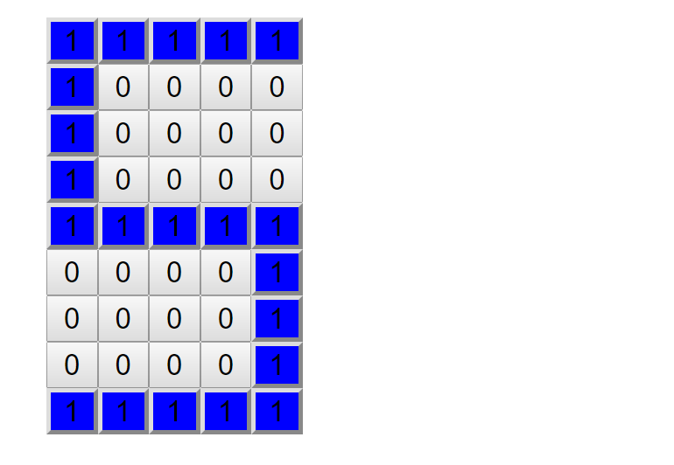

## RGB Table

Write a PHP script that draws a table with 3 columns, with captions – **Red**, **Green** and **Blue**, and 5 rows, each having as **background** **1** of **5** shades of those colors. Increase the color index by **51** for each row. For example, for the Red Column it will be:

* RGB(51, 0, 0)
* RGB(102, 0, 0)
* RGB(153, 0, 0)
* . . .

The caption columns should **NOT** be colored. Each cell of the table has **width** and **height** equal to 50px and has 1px **solid** **black** **border**.

### Picture:

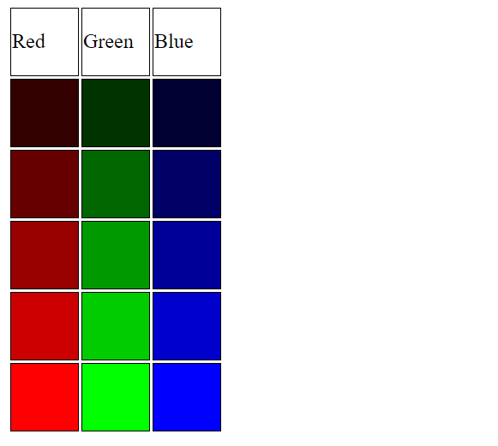

## 50 Shades of Grey

Write a PHP script that generates 5 rows of 10 <div> **elements**, each having as background a different shade of grey – resulting in 50 shades of grey. Every row starts with a color index – a **multiple of 51**.

* First row – 0,
* Second row – 51,
* Third row – 102 …

Then you need to print **10 divs**, each increasing that index with **5.**

* First row – 0, 5, 10…
* Second row – 51, 56, 61…

The color index needs to be applied to **all** **parameters** of the **RGB function**. Example: rgb(51, 51, 51);

### Picture:



There is no indentation on the elements.